Python Geometry 1

These exercises are all focused on geometry with Python.

All of the required maths knowledge is from GCSE (Pythogoras, tangent etc.)

Printing text

If you print text, the screen will switch to text mode.
If you use the turtle, the screen will switch to graphics mode.
You can switch between them using the options menu on the webpage.

print(“x”) | Prints the letter “x” on the screen.
print(x) | Prints the value of the variable x on the screen.

Using the maths commands

The commands needed for these exercises are shown below:

pi | This gives you an accurate value of π
x ** 2 | Raise x to the power of 2 (= x²)
sqrt(x) | Take the square root of x
tan(t) | Calculate the tangent of angle t, in degrees.
atan(x) | Calculate the inverse tangent (or arctangent) of x

Using the turtle

You can look at the example on the website for more help.

fred = Turtle() | Create a new turtle called “Fred”
fred.go(100) | Tell Fred to go forward 100 pixels.
fred.turn(90) | Tell Fred to rotate anti-clockwise 90°.
fred.turn(-90) | Tell Fred to rotate clockwise 90°.

1. The right angled triangle ABC is 100 pixels across and 100 pixels high, as shown below.

a) Calculate the angle ∠CAB.
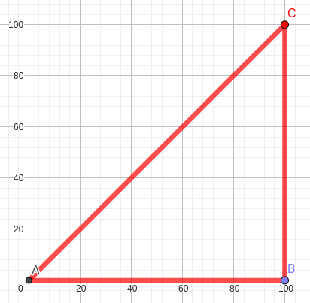
∠CAB =

b) Print the length of the side AC on the console.

Length |AC| =

c) Write code to draw this triangle accurately
using the Python turtle.

2. Another right angled triangle is 100 pixels across and 200 pixels high.

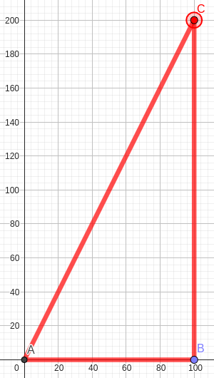
a) Calculate the angle ∠CAB.

∠CAB =

b) Print the length of the side AC on the console.

Length |AC| =

c) Print the area of triangle ABC on the console.

Area ABC =

d) Write code to draw this triangle accurately
using the Python turtle.

3. The square ABCD is 100 pixels on each side.
There is another square rotated 45° inside.

The points E, F, G and H are midpoints on each side of the square.

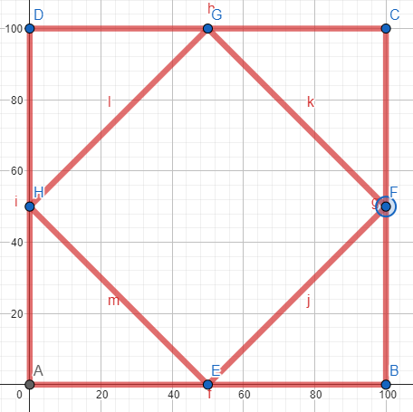
a) Calculate the angle ∠BEF.

Angle ∠BEF =

b) Print the length of the line EF on the console.

Length |EF| =

c) Write code to draw both squares accurately
using the Python turtle.

4. The square JKLM is 100 pixels on each side.
There is a regular octagon inside the square.

The points B, D, F and H are midpoints on each side of the square.
The points B, D, F and H are also four of the octagon’s vertices.
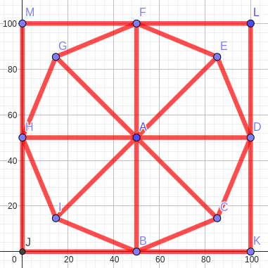
a) Calculate the length of the line AB.

Length |AB| =

b) Print the length of the line BC on the console.

Length |BC| =

c) Write code to draw the square and the
octagon accurately using the Python turtle.

5. A circle is drawn inside the right-angled triangle from question 2.
The point F is the midpoint of A and C.

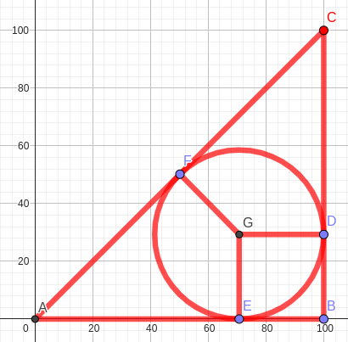
a) Print the length of the line AF on the console.

Length |AF| =

b) Print the length of the line FG on the console.

Length |FG| =

d) Print the length of the line AE on the console.

Length |AE| =

e) Write code to draw the triangle and the
circle inside it accurately using the Python
turtle. You don’t need to include the
lines GF, GD, or GE.

6. BCDEF is a regular pentagon.
The point M is the midpoint of the side ED.
The height of the pentagon, |MB| is exactly 100 pixels.
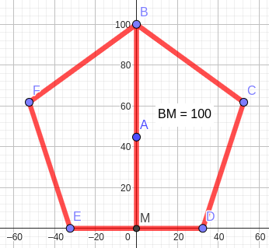
a) Print the length of the line AB on the console.

Length |AB| =

b) Print the length of the line AM on the console.

Length |AM| =

c) Write code to draw the pentagon
accurately using the Python turtle.

